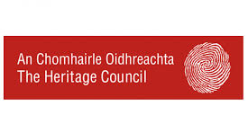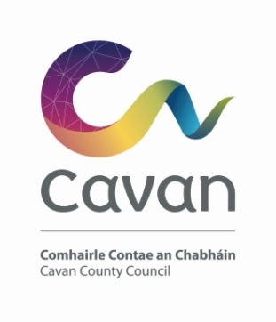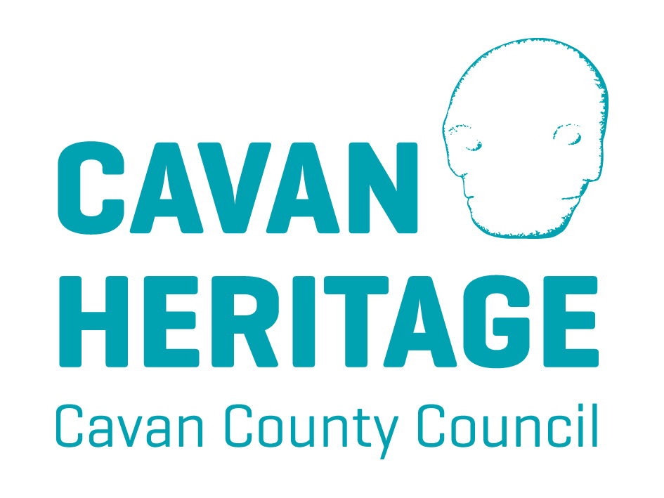
Heritage Week Grant Application Form
Heritage week runs from 16th – 24th August, 2025
This year’s theme “Exploring our Foundations” invites you to delve into the building blocks of our heritage; not just the structures, but the landscapes and cultural activities that have shaped us.
The Heritage Office is making small funding grants available to assist groups and individuals organising heritage week events throughout the county.
In order to be eligible for funding, each project must be listed on the National Heritage Week 2025 portal by the individual groups / project organisers. Failure to do so will result in non-payment of grant from the Heritage Office.
Contact Details
Name of Group / Organisation
Contact person
Contact No
Postal address for all group correspondence
Eircode
Email address

Event Details
Event Title: ____________________________________________________________
Venue: ____________________________________________________________
Commencement date of the event: ___________________
End date of the event: ___________________
Time: From __________________ To ______________________

Description of Event:
Please give details of your proposed event: (additional information may be attached to this application)

Admission Fee Yes ☐ No ☐
Booking required Yes ☐ No ☐
Purpose of Grant (e.g. Speaker fee, venue hire, refreshments etc)

How will the event be advertised?

How will you acknowledge the Heritage Office & Cavan County Council ?

Payment Details (if differ from Contact Details)
Name
Address

Event Costs
Please provide details of proposed costs associated with the event.
Item | Cost
 | €
 | €
 | €
 | €
 | €
 | €
Total | €

How much are you requesting from this Grant Application? | €

Please note that the amount requested is not guaranteed, if this occurs how do you propose to fund the shortfall for the event:

If events are taking place in recorded monument (RMP) sites or Natura 2000 sites, i.e. SAC/SPA sites consent maybe needed.
Checklist to be completed before submission of Application Form
- Signed application form – completed in full. ☐

- Signed Agreement Form ☐

Finance and Drawdown of Funds
The full 100% of the grant can be drawn down on completion of the event and only on producing the relevant eligible proof of payment.
GDPR
Cavan County Council is committed to fulfilling its obligations imposed by the Data Protection Acts 1988 to 2018 and the GDPR. Our privacy statement and data protection policy are available at Data Protection Policy - Cavan County Council (cavancoco.ie)
We request that you read these as they contain important information about how we process personal data. I consent to the collection and processing of the data provided by me to Cavan County Council. I have completed all relevant sections of this application form and confirm that all information provided is truthful and accurate.
Signed on behalf of applicant / community group.
Name
Signature
Position in Group
Date

NOTE: Closing date for receipt of applications to the Heritage Office is Friday 27th June 2025
Please return to: Anne Marie Ward, Heritage Officer, Johnston Central Library, Farnham Street, Cavan
or cavanheritage@cavancoco.ie
Heritage Week 2025 – Grant Conditions & Agreement Form

Please read all guidelines carefully before signing and return a copy of this agreement.

Name of Group / Organisation: ______________________________________________________________
- We certify that the information provided in this application is a true and fair representation of the group’s activities and the event for which is being sought. We have read the relevant guidelines and will comply with same.

- We undertake to ensure that any grant awarded to us by Heritage Office, Cavan County Council under this application will be used for the specific purpose for which it has been granted.

- We will acknowledge the support of the Heritage Office, Cavan County Council in any publicity pertaining to the event and to submit proof of same with our final event report. We will endeavour to tag Cavan Heritage Office and Cavan County Council on any social media posts relating to the event.

- We agree that any photographs submitted by us may be used by Cavan Heritage Office on their website, social media or otherwise in promoting Heritage and Heritage Week. The necessary permissions will be obtained and retained by us in accordance with Data Protection legislation.

- On completion of works, we undertake to submit proof of payment in relation to expenditure incurred on our event within 3 weeks of event taken place to Heritage Officer, Cavan County Council, Farnham Street, Cavan

- We understand that the Heritage Office, Cavan County Council shall not be liable in respect of any loss, damage or costs of any nature arising directly or indirectly from this application or the subject matter of the application. Cavan County Council, its employees or agents shall not at any time in any circumstances be held responsible or liable in relation to any matter whatsoever arising in connection with the development, planning, construction, operation, management and / or administration of individual events.

- Finance and Drawdown of Funds - The full 100% of the grant can be drawn down on completion of the event and only on producing the relevant eligible proof of payment.

- Freedom of Information Applicants completing this form please note that information provided to Cavan County Council may be disclosed in response to a request made under the Freedom of Information Act (1997 & 2003). However, every effort will be made to protect confidentiality particularly in relation to commercially sensitive material.
Signed for, and on behalf of, the group
Signature: ______________________________________ Position: ______________________________
Date: ___________________
A signed copy of this form must be included with your application form.

