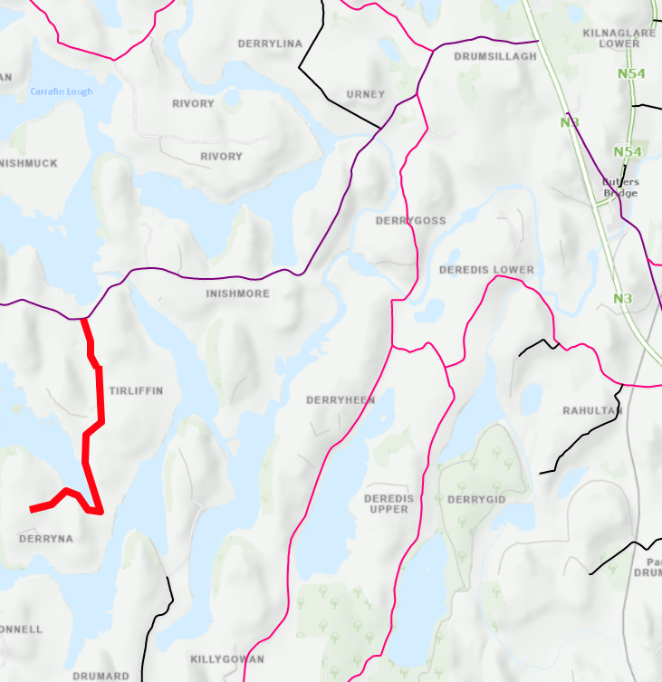

Road Closed

L-15083-0 Derryna Lane (Tirliffin) Road Closure

