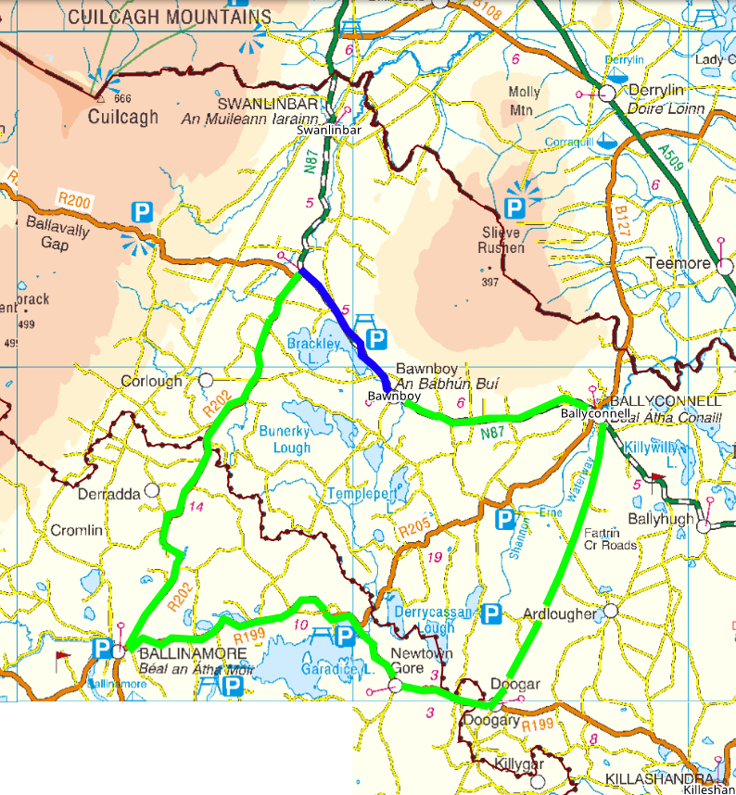
Road Closed
Diversion Route
Diversion Route for N-87 Bawnboy to Derrynacreeve

