**Cavan Library Service Classroom Novels**

Cavan Library Service is delighted to offer Primary Schools the opportunity to borrow multiple copies of a selected title for use as a classroom novel. Each of the titles below has been carefully chosen by library staff to cater for varying reading abilities and a range of interests.

**1.** **Begone the Raggedy Witches**

* The standard block-loan period is 4 weeks.
* Availability of titles is dependent on demand.
* Teachers must be registered through their school with a signed guarantee from the school principal.
* Find out more at [www.cavanlibrary.ie](http://www.cavanlibrary.ie) or ring your local library.

by Celine Kiernan (Cavan Author)

On the night that Aunty dies the Raggedy Witches come for Mup's mam. When they kidnap Mup's dad, Mup and her mam must leave the mundane world to rescue him. Even if they can save Dad, Mup is not sure anything will ever be the same again...

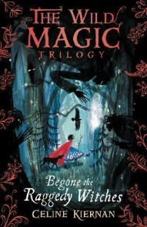

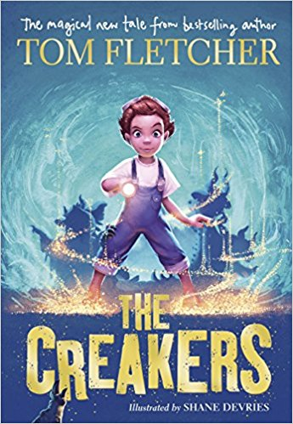**2. The Boy Who Swam with Piranhas**

**3. The Creakers** by Tom Fletcher

One morning, Lucy discovers that all the grown-ups have disappeared! Chaos descends as kids run riot. But Lucy lost her dad not long ago, and she's determined not to lose her mum too. She's going to get her back - and nothing is going to stop her!

By David Almond

A boy escapes home to seek his own way in the world and mingles with a carnival full of eccentric characters. Will Stan be bold enough to choose his own destiny?

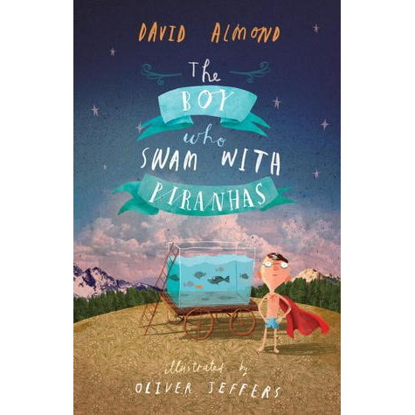

**4. The Parent Agency 5. Stay Where You Are and Then Leave**

When the 1st World War broke out, Alfie’s father goes away to fight. Alfie doesn't know where his father is but finds out he is in a hospital treating soldiers with an unusual condition. Alfie is determined to rescue his father from this strange, unnerving place . . .

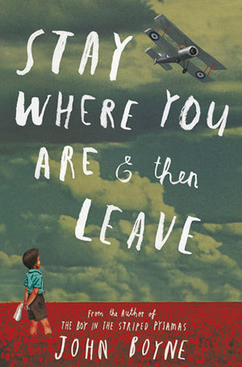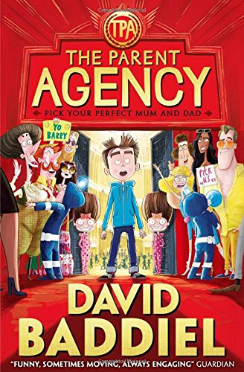By David Baddiel By John Boyne

A boy travels to an alternate world where kids get to choose their own parents in this zany, internationally bestselling adventure, which combines the be-careful-what-you-wish-for humour with the classic appeal of Roald Dahl.

1. **The Boy in the Striped Pajamas 7. The Wizard of Once**

Berlin 1942. Bruno must move to a new house far, far away, where there is no one to play with and nothing to do. A tall fence cuts him off from the strange people he can see in the distance.    
While exploring he meets another boy and their friendship has devastating consequences.

By John Boyne By Cressida Cowell

A boy wizard and girl warrior have been taught to hate each other like poison. This is a thrilling tale of what happens when their two worlds collide. Perfect for boys and girls who love fantasy adventure ....

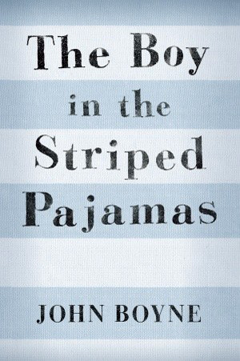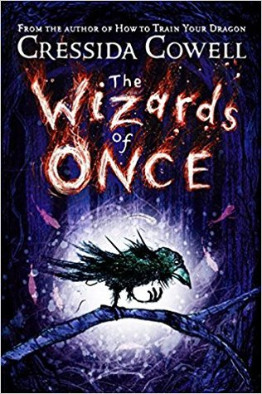

**8. George’s Marvellous Medicine 9. Rover and the Big Fat Baby**

by Roald Dahl by Roddy Doyle

The BFB (Big Fat Baby) is missing! While Rover and Co. are hot on the trail of the BFB it looks like the Gigglers are about to run out of poo . . . Without an urgent delivery from Rover, how will they be able to give the Giggler Treatment to grumpy adults and help kids all over the country?

George's Grandma is grizzly, grumpy and selfish. Four times a day she takes a large spoonful of medicine, but it doesn't seem to do her any good. When George is left to look after her one morning, it's just the chance he needs . . .

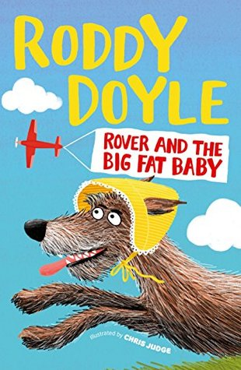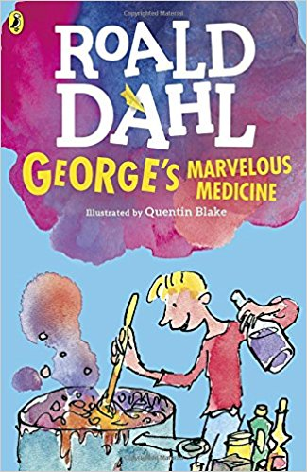

**10. Whistling in the Dark 11. One Dog and his Boy**

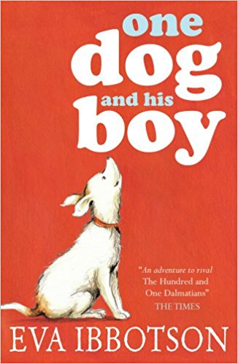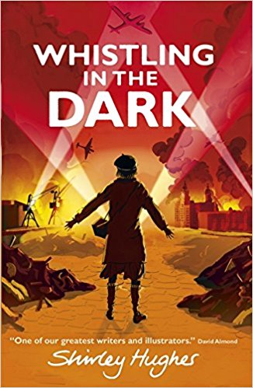by Shirley Hughes by Eva Ibbotson

On the morning of his10th birthday, Hal is allowed to choose a puppy at Easy Pets, a rent-a-pet agency. But no one tells Hal that Fleck must be returned and when Hal wakes up on Monday morning, Fleck is gone. If dog and boy are to stay together they'll have to run away...

Liverpool, 1940: thirteen-year-old Joan’s home is under threat from the Nazi’s terrifying nightly air-raids. An army deserter found lurking near where Joan and best friend Doreen’s home. Who is he and why does he think Joan can help him?

.

**12. The Abominables 13. Sky Hawk**

Callum and friends find Iona on Callum's farm and try to chase her back into the village. Worried for Iona's safety, Callum follows her and finds she is guarding a secret hidden in the forest above the dark waters of the loch. They form a deep bond of friendship and make a promise that will change Callum's world forever.

by Eva Ibbotson by Gill Lewis

Renowned literary great Eva Ibbotson delivers a final novel in her much-loved style. A previously unpublished work, *The Abominables*follows a family of yetis who are forced, by tourism, to leave their home in the Himalayas and make their way across Europe to a possible new home.

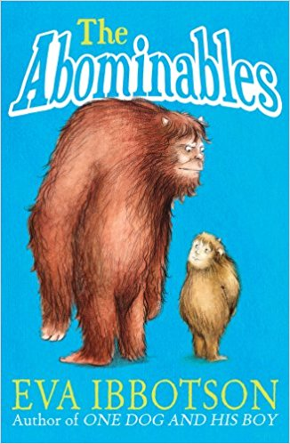

**14. Clare and her Captain**

by Michael Morpurgo

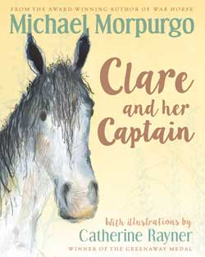

Summer means staying with Aunt Dora in the Devonshire countryside with Mum and Dad arguing all the time. Clare is fed up with it, until she finds friendship with retired horse Captain and his reclusive owner.

**15. Grandpa’s Great Escape 16. Wave Me Goodbye**

by David Walliams by Jacqueline Wilson

Jack’s Grandpa…  wears his slippers to the supermarket,  
serves up tinned tongue for dinner and often doesn’t remember Jack’s name but he can still take to the skies in a speeding Spitfire and save the day… An exquisite portrait of the bond between a small boy and his beloved Grandpa.

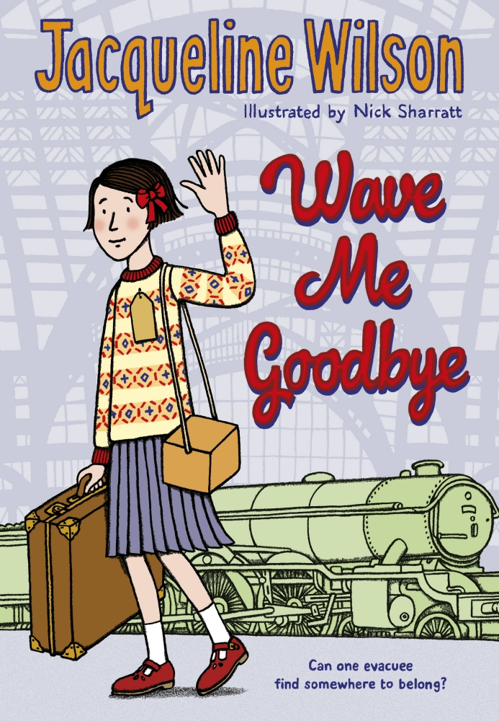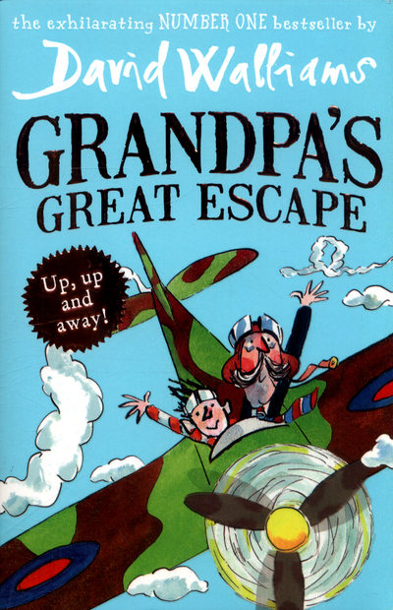

September 1939. As war begins, Shirley is sent away. She doesn’t know where she’s going, or what’s going to happen to her. She is billeted in the country, with two boys and their experiences living in the strange, half-empty Red House, with the mysterious Mrs Waverley, will change their lives forever.

**17. Clover Moon 18. Danny Champion of the World**

by Jacqueline Wilson by Roald Dahl

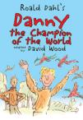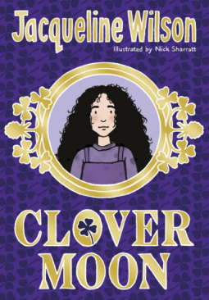

Roald Dahl’s famous story about a 9-year-old boy, his dad and their daring and hilarious pheasant-snatching expedition.

.

Clover Moon lives in a slum in Victorian England. Her wicked stepmother cares very little for her and beats her given any opportunity. Life in Cripps Alley is grim and when she loses the one person she loves most in the world, her sister Meg she plans to escape Cripps Alley. She runs away to a home for destitute girls, where a new realm of challenges and surprises awaits her.

**19. The London Eye Mystery 20. The Giggler Treatment**

by Siobhán Dowd by Roddy Doyle

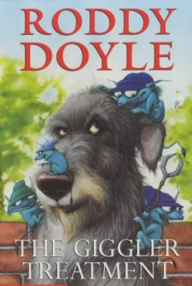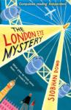

The gigglers are mischievous creatures who take revenge on any adult who mistreats a child.

The London Eye Mystery tells of how Ted and Kat, try to find out what happened to their cousin Salim, who got onto the London Eye & never got off.

**21. When Jessie Came Across the Sea 22. The Easter Rising 1916: Molly’s Diary**

Easter 1916. Caught up in the action in Dublin, is twelve-year-old Molly. Her own family is plunged into danger on both sides of the conflict. Will the family survive and will she be able to save her brother? This is her diary.

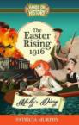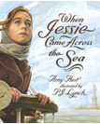by Amy Hest by Patricia Murphy

The story of a young Jewish girl who leaves her grandmother to emigrate to a new life in America.

.

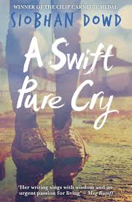

**23. A Pure Swift Cry YOUNG ADULT THEMES Suitable for Secondary School Only**

by Patricia Murphy

After Shell's mother dies, her obsessively religious father descends into alcoholic mourning and Shell is left to care for her younger brother and sister. Her only release from the harshness of everyday life comes from her budding spiritual friendship with a naive young priest, and most importantly, her developing relationship with childhood friend, Declan, charming, eloquent and persuasive. But when Declan suddenly leaves Ireland to seek his fortune in America, Shell finds herself pregnant and the centre of a scandal that rocks the small community in which she lives, with repercussions across the whole country. The lives of those immediately around her will never be the same again. she be able to save her brother? This is her diary.

**25. The Railway Children**

by E. Nesbitt

A timeless tale of blissful independence and adventure. Peter, Phyllis and Roberta’s lives change overnight when their father is taken away by two strangers. They move from the comfort of their London home to a small country cottage and are left to their own devices while their mother writes day and night to support the family. But with their new poverty comes more freedom than they ever dreamed of, and the railway line at the bottom of their garden offers the trio a world of new friendships that will change their lives forever.

**24. Goodnight Mr Tom**

by Michelle Magorian

A tender and beautifully evoked story which sweeps readers back into the Second World War era. When the war thrusts scrawny evacuee Willie Beech into the care of a gruff old man, an unlikely bond flourishes between them. But as Willie enjoys his first ever taste of kindness, suddenly his happiness is under threat again…

www.cavanlibrary.ie