Cavan Library Service
Group School / Group Membership
Rules and Regulations

- Each Group Leader / Teacher must register his / her class / group for the year, by filling in the Group Membership Form.

- Forms are available at your local library or to download at www.cavanlibrary.ie.

- The Group Membership Form must be signed by a Guarantor e.g. School Principal with school stamp.

- Pre-school classes, Primary School and Secondary School classes may borrow up to a maximum of 40 books

- General Groups may borrow up to a maximum of 40 books

- The Group Leader / Teacher is responsible for books borrowed at all times and must ensure that all books are checked in / checked out at the library desk at each visit.

- The Group Leader / Teacher is responsible for ensuring that children do not access inappropriate material. Use our reading levels to guide you in selecting books.
- The Group Leader / Teacher may renew specific titles again if required, but must ensure that the full quota of books is brought to the library on each visit.
- The Group Leader / Teacher must ensure all books are located in the Preschool / School at all times.

- All books to be returned in May prior to the end of the school year.

- The Preschool / School is responsible for the replacement cost of any damaged or lost books.
- Take care of library materials, equipment and premises. If you damage any of these, you will have to meet the cost of same.

- We adhere to National Child Protection Guidelines. Library staff cannot be responsible for the supervision of children. Children should be accompanied by an adult at all times.

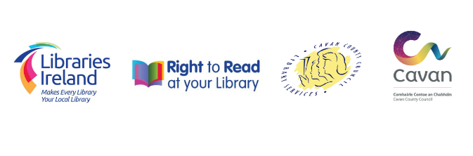
Remember: We comply with Health & Safety Legislation and provide a safe place for all users and staff. Any member of the public causing difficulty for others or for library staff will be asked to leave the library. We reserve the right to refuse entry and / or restrict services.

www.cavanlibrary.ie

