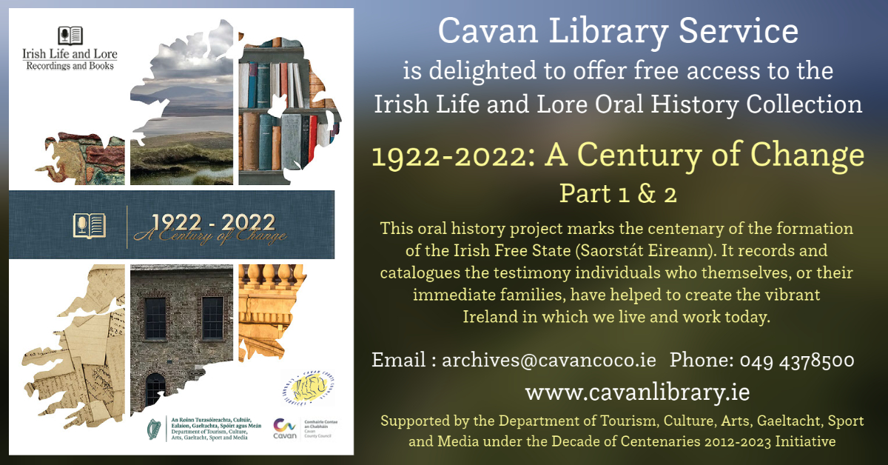

1922-2022: A Century of Change
Part 1 & 2

I give an undertaking not to publish, broadcast, or reproduce in any medium the said material or any part, extract, or resume thereof.

Name:

Library Card number:

Date:

